# Big Data Hadoop and Spark Developer

# Project -3. Market Analysis in Banking Domain

1. Load data

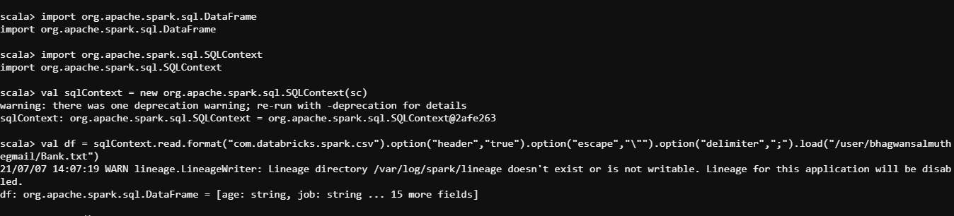

Show data

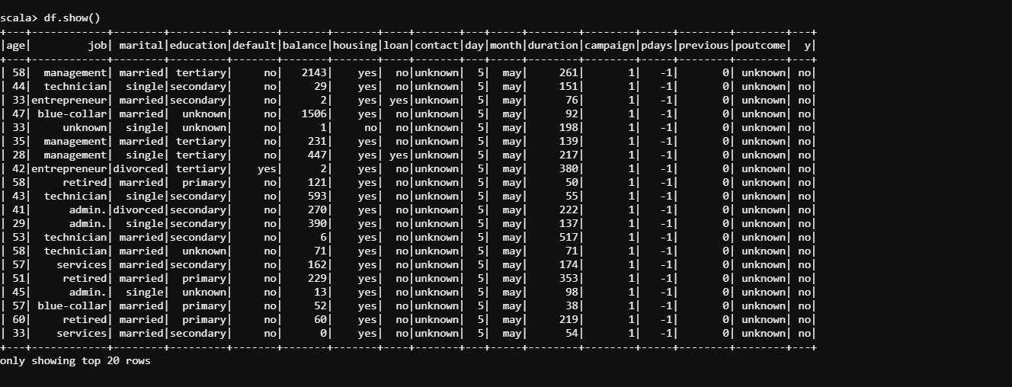

1. Give marketing success rate

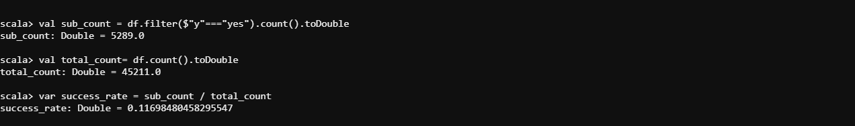

Give marketing failure rate



1. Give the maximum, mean, and minimum age of the average targeted customer

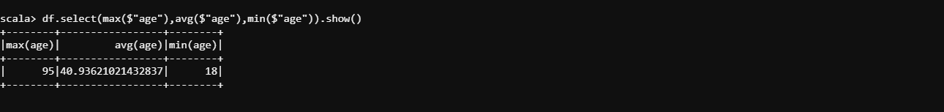

1. Check the quality of customers by checking average balance, median balance of customers



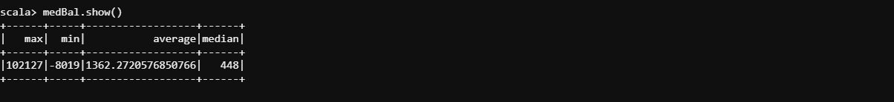

1. Check if age matters in marketing subscription for deposit

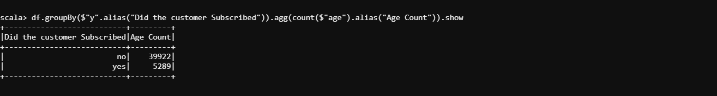

1. Check if marital status mattered for a subscription to deposit

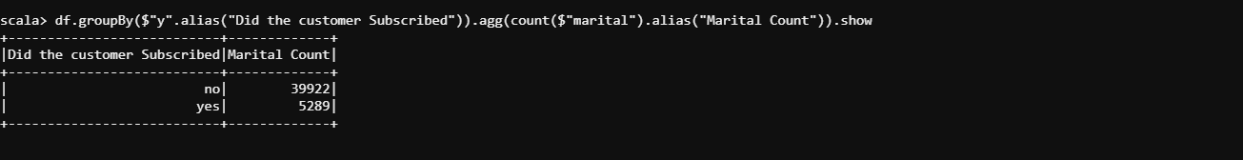

1. Check if age and marital status together mattered for a subscription to deposit scheme

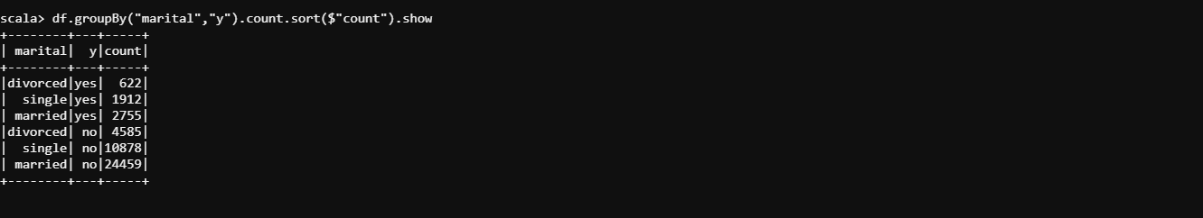

1. Do feature engineering for the bank and find the right age effect on the campaign.

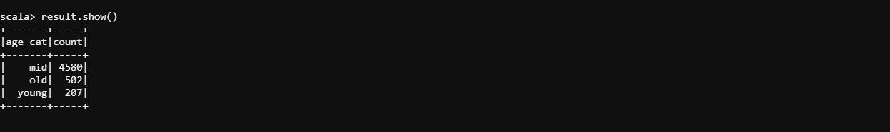

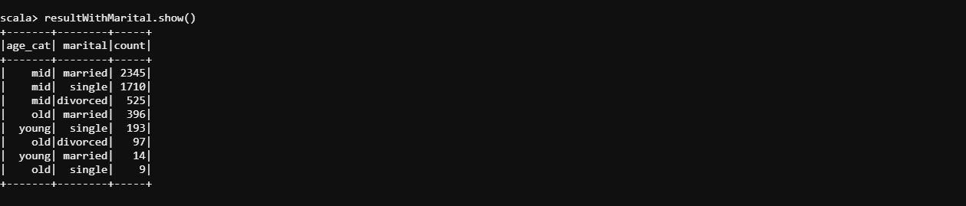

Correlation Analysis

Convert "y" (If the person subscribed after the marketing strategy) to dummy

Dummy column will be called "bin"

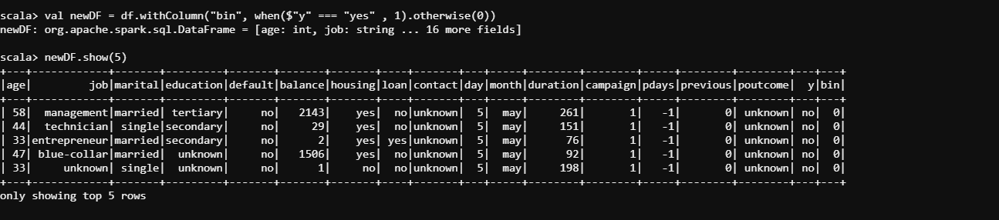

Prepare Data for Correlation Analysis



Correlation between People that subscribed to the bank and the age of the marketing group

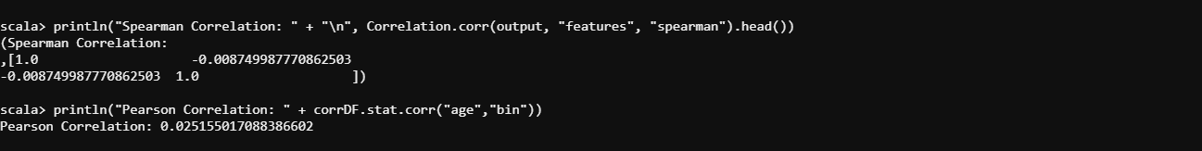

# KMeans Analysis

Kmeans Implementation

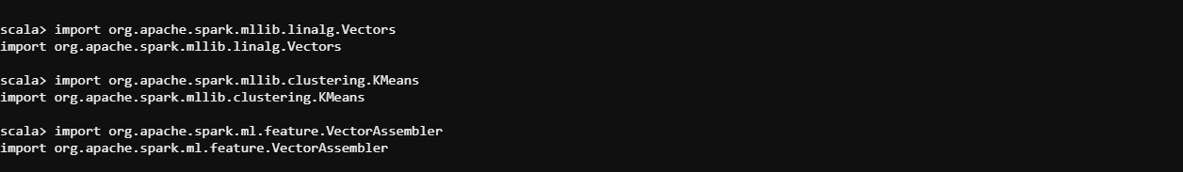

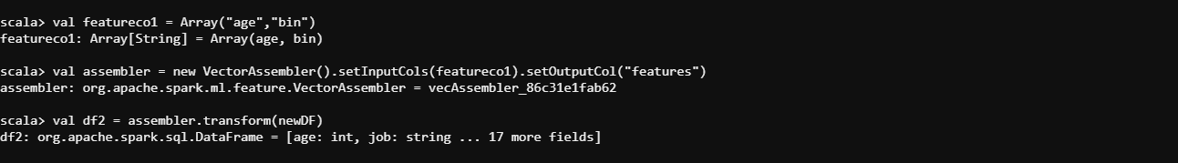

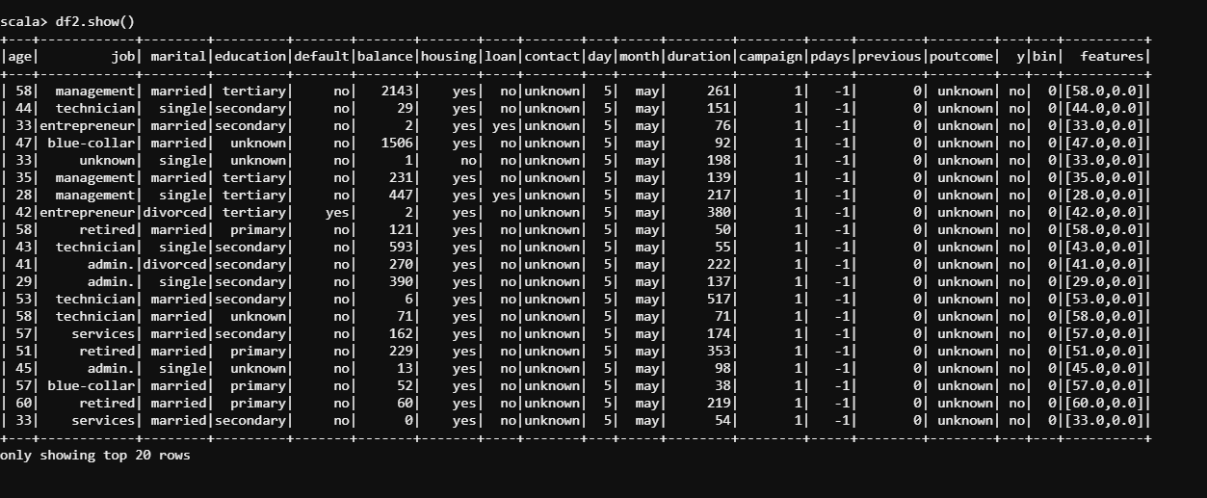

Train Test Split

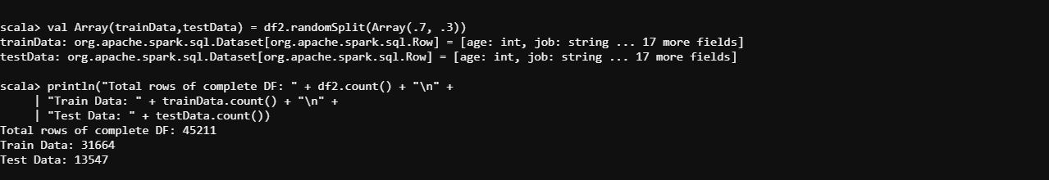

KMeans Algorithm

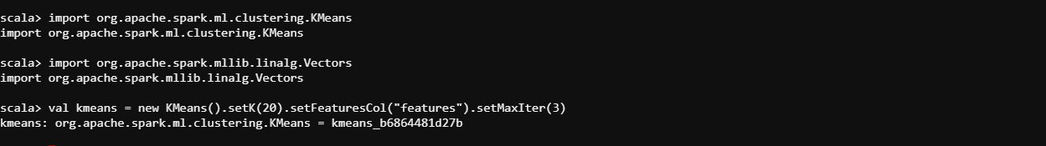

Fit KNN Model



Predict Test Data

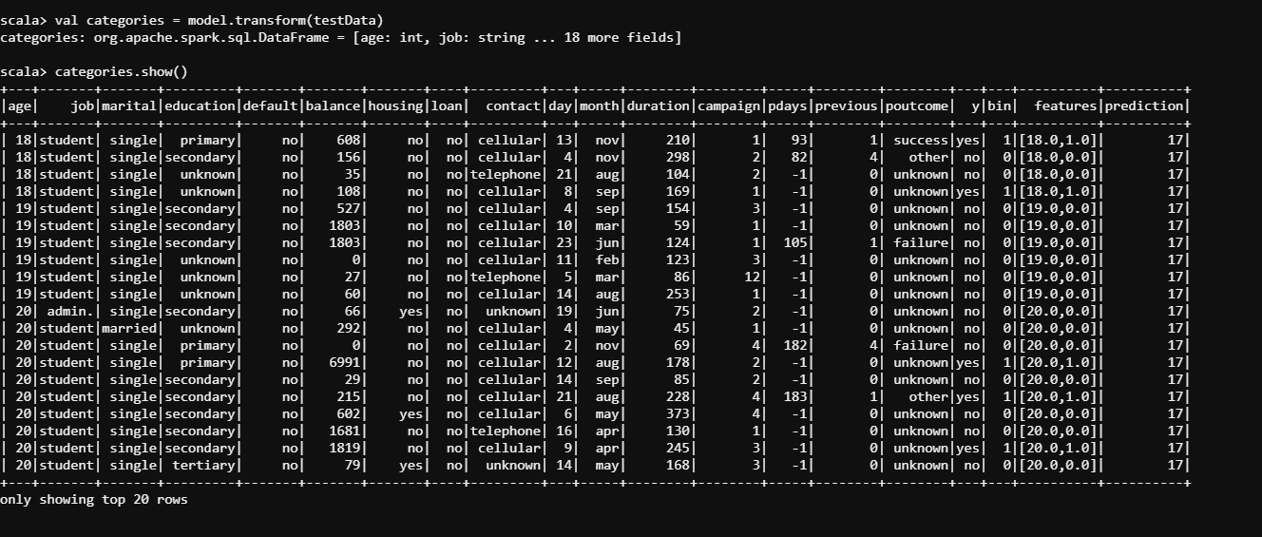

Now we need can visualize each age per cluster

Check the 100 records.



